Experiment–1
Title: Study of Different Types of Network Cables and Practical Implementation of Cross-wired and Straight-through Cable using Clamping Tool

Aim
To study various network cables and practically create a cross-wired cable and a straight-through cable using a twisted pair cable, RJ-45 connectors, and a crimping tool.

Apparatus / Components Required
- RJ-45 Connectors (2 for each cable)
- Crimping Tool
- Cable Stripper / Cutter
- Twisted Pair Cable (Cat5e / Cat6)
- Network Cable Tester

Theory
Network cables are essential for wired communication in computer networks. Twisted Pair Cables are the most commonly used in LANs, especially Category 5e (Cat5e) and Category 6 (Cat6) cables.
They can be terminated in two wiring standards: T568A and T568B.
1. Straight-through Cable
- Both ends follow the same wiring standard (T568A–T568A or T568B–T568B).
- Used to connect different devices (e.g., PC to Switch, Switch to Router).
2. Cross-over Cable
- One end follows T568A, the other end follows T568B.
- Used to connect similar devices (e.g., PC to PC, Switch to Switch).
Colour Codes:
- T568A:
  - White-Green
  - Green
  - White-Orange
  - Blue
  - White-Blue
  - Orange
  - White-Brown
  - Brown

- T568B:
  - White-Orange
  - Orange
  - White-Green
  - Blue
  - White-Blue
  - Green
  - White-Brown
  - Brown
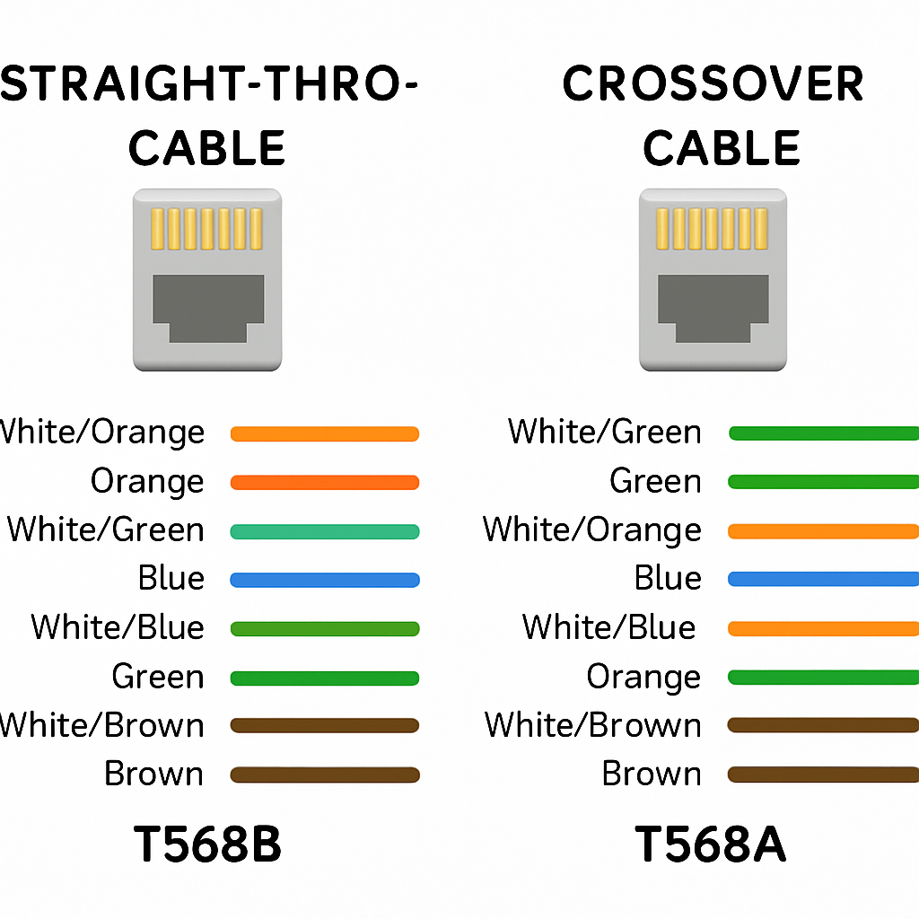

Procedure
- Strip Cable Jacket – Using a cable stripper, remove about 2 inches of the outer jacket without damaging the internal wires.
- Separate and Arrange Wires – Untwist and align wires according to the T568A or T568B standard.
- Prepare Cable Ends –
  - For Straight-through: Arrange both ends in the same standard.
  - For Cross-over: Arrange one end as T568A and the other as T568B.
- Trim Wires – Cut all eight wires evenly to about 0.5 inch from the jacket.
- Insert into RJ-45 Connector – Push wires into the connector ensuring they are in the correct slots and fully seated.
- Crimp Connector – Place the connector into the crimping tool and press firmly to secure.
- Test the Cable – Use a network tester to verify correct pin connections.

Result/Conclusion
We have successfully studied and implemented straight-through and cross-over network cables using twisted pair cable, RJ-45 connectors, and a crimping tool, and tested their working using a cable tester.

Viva Questions
- What is the difference between straight-through and cross-over cables?
- What are the wiring color codes for T568A and T568B standards?
- Which cable is used to connect two PCs directly?
- What is the function of the RJ-45 connector?
- Why should we minimize the untwisting of twisted pair cables?
- What is the maximum cable length allowed for Ethernet using twisted pair cable?
- Why do we use a network tester after making cables?
- Which category of cable supports Gigabit Ethernet?

